**Lesson Summary and Revision Notes: Week 13**

What is Computational Thinking ?

Computational Thinking is the process of breaking down a problem into simple enough steps that even a computer would understand.

3 Common Techniques in Computational Thinking

1. Abstraction
2. Decomposition
3. Pattern Recognition

Define what is Abstraction in Computational Thinking ?

* **Abstraction**:
  + Abstraction enables computer scientists to develop clear models for the solution to complex problems.
  + Abstraction involves extracting information that is essential while ignoring what is not relevant, and only including what is necessary to solve that problem.
  + Abstraction encourages the development of simplified models that are suited to a specific purpose by eliminating any unnecessary characteristics from that model.
  + Many everyday items use abstraction (eg: maps, calendars and timetables) to highlight the important information and exclude those that are unnecessary.

Benefits of Abstraction

The Benefits of eliminating any unnecessary characteristics from the model include:

* Time required to develop the program is reduced and program can be delivered to the customer more quickly.
* Program is smaller in size so takes up less space in memory and download times are shortened.
* Customer satisfaction is greater as their requirements are met without any extraneous features.

Explain what is Decomposition in Computational Thinking ?

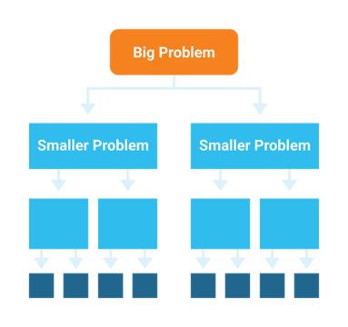

* **Decomposition:**
  + Decomposition in computational thinking is the process of breaking down a problem into a number of smaller problems that can more easily be addressed.
  + It is an effective method of solving complex problems as it helps to identify patterns, eliminate extra details and solve the problem step by step instead of trying to do so all at once.
  + Problems we encounter throughout our daily lives are ultimately composed of smaller problems we can more easily address.
  + This process of breaking down problems enables us to analyze the different aspects of them, and have a better understanding of the problem.

Explain what is Pattern Recognition in Computational Thinking?

* **Pattern Recognition:**
  + Pattern recognition is about recognizing patterns and connections among the different pieces of the larger problem.
  + These patterns can be both shared similarities and shared differences.

* + Pattern recognition is essential to building understanding from dense information and data.

Why is Pattern Recognition Important ?

* Finding patterns is extremely important because patterns make our task simpler.
* Problems are easier to solve when they share patterns, because we can use the same problem-solving solution wherever the pattern exists.
* The more patterns we can find, the easier and quicker our overall task of problem solving will be.

Give Some Examples of How Pattern Recognition is Useful in Everyday Life

* **Epidemiology**: Scientists identify the cause of a disease outbreak by looking for similarities in the different cases to determine the source of the outbreak.
* **Mathematics**: Students recognize the specific formulas used to calculate slopes (gradients) and intercepts.
* **Science**: Students classify animals based on their characteristics and articulate common characteristics for the groupings.
* **Languages**: Students group different words in a foreign language by looking at their roots to build a better understanding of vocabulary.